**QSMART – COOLANT CONNECTING REPLACEMENT**

**PROCEDURE**

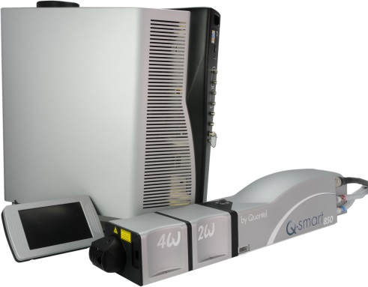

**Toolkit:**

Screwdrivers

Allen keys

**System**: QSMART

|  |  |
| --- | --- |
| RP130014A | **Q-SMART COOLANT CONNECTING SET** |

**Purpose**: This document details how to change the coolant connecting set

|  |  |  |
| --- | --- | --- |
| Revision | date | modification |
| Initial issue | July 4, 2014 |  |
|  |  |  |
|  |  |  |
|  |  |  |

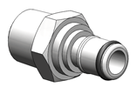

# DISASSEMBLING

* Turn the system off
* Disconnect cables and water hoses from the side of the laser head side
* Remove the laser head cover.
* Remove the side plate (7 BHC 3x6)

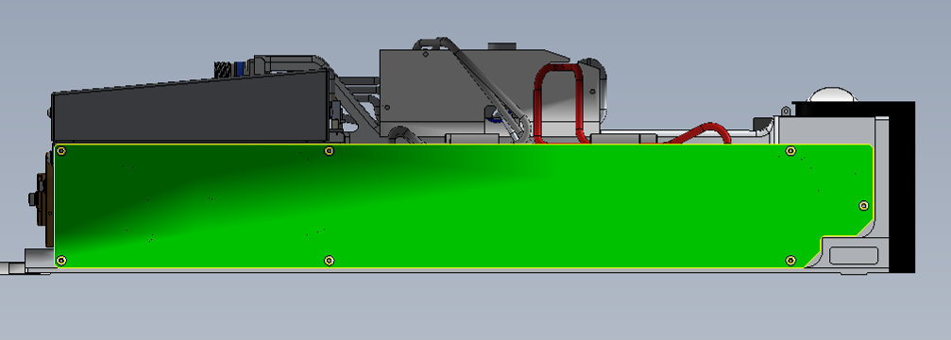

* Unscrew and remove the coolant connecting

# IMPLEMENTATION OF THE NEW COOLANT CONNECTING

* Clean the threaded holes (acetone)
* Put a Teflon tape on the threads of each threaded opening APC 3/E10/0678 and screw them into the foundry
* 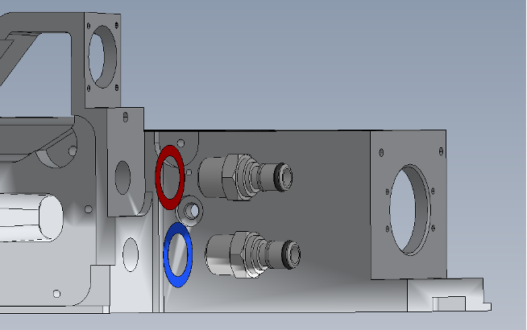 Do not tighten to the maximum, you should still see apparent threads.
* Close the Laser head and put warranty stickers   
  *Refer to "LH-Warranty Labels"*